Sandy Hill Academy
Teaching and Learning Principles
Subject: Mathematics

Mission Statement:
‘Aspiring to achieve, determined to succeed’
Vision:
The mathematics curriculum at Sandy Hill has been designed to ensure that children possess the skills and knowledge that will affect them positively in their lives. Concepts have been carefully sequenced to enable learners to make connections, building upon prior knowledge. At the heart of the curriculum, driven throughout each academic year, will be fundamental fluency/arithmetic skills.

We aim to:
- Ensure that every child possesses key fluency skills to enhance their self-confidence and enjoyment of mathematics in order to develop their understanding of the world.
- Develop pupils’ reasoning skills using precise mathematical vocabulary
- Build pupils’ understanding through applying their skills to problem-solving activities and real-life links

Mathematics Expectations (National Curriculum 2014):
The National Curriculum for Mathematics aims to ensure that all pupils:

- Become fluent in the fundamentals of mathematics, including through varied and frequent practice with increasingly complex problems over time, so that pupils develop conceptual understanding and the ability to recall and apply knowledge rapidly and accurately.

- Reason mathematically by following a line of enquiry, conjecturing relationships and generalisations, and developing an argument, justification or proof using mathematical language

- Can solve problems by applying their mathematics to a variety of routine and non-routine problems with increasing sophistication, including breaking down problems into a series of simpler steps and persevering in seeking solutions.

Mathematics is an interconnected subject in which pupils need to be able to move fluently between representations of mathematical ideas. The programmes of study are, by necessity, organised into apparently distinct domains, but pupils should make rich connections across mathematical ideas to develop fluency, mathematical reasoning and competence in solving increasingly sophisticated problems. They should also apply their mathematical knowledge to science and other subjects. The expectation is that the majority of pupils will move through the programmes of study at broadly the same pace. However, decisions about when to progress should always be based on the security of pupils’ understanding and their readiness to progress to the next stage. Pupils who grasp concepts rapidly should be challenged through being offered rich and sophisticated problems before any acceleration through new content. Those who are not sufficiently fluent with earlier material should consolidate their understanding, including through additional practice, before moving on.

EYFS
Within the EYFS Framework 2021, Mathematics is known as a ‘specific’ area.

‘Developing a strong grounding in number is essential so that all children develop the necessary building blocks to excel mathematically. Children should be able to count confidently, develop a deep conceptual understanding of the numbers to 10, the relationships between them and the patterns therein. By providing frequent and varied opportunities to build and apply this understanding – such as using manipulatives – children will develop a secure base of knowledge from which mathematical mastery is built. In addition, children’s curiosity about number, shape, space and measure should be encouraged and furthered through opportunities to apply their growing understanding of the mathematical world to the world around them.’

Area | Early Learning Goals (ELG)
Numbers | *Have a deep understanding of number to 10, including the composition of each number.  *Subitise (recognise quantities without counting) up to 5.  *Automatically recall (without reference to rhymes, counting or other aids) number bonds up to 5 (including subtraction facts) and some number bonds to 10, including double facts.
Numerical Patterns | *Verbally count beyond 20, recognising the pattern of the counting system.  *Compare quantities up to 10 in different contexts, recognising when one quantity is greater than, less than or the same as the other quantity.  *Explore and represent patterns within numbers up to 10, including evens and odds, double facts and how quantities can be distributed equally.

In our Nursery and Reception classes, aspects of Mathematics are taught on a daily basis through: whole class/small group teaching, continuous provision areas and outdoor activities. Children have lots of opportunities to hear, discuss and explore mathematics- adults reflect upon learners’ requirements, interests and the ways they learn best, to support effective planning and provision

We use Tapestry, our online learning journal, to record and track children’s progress and achievements in Mathematics against the ELGs. Children who need additional support are identified and interventions are put in to place when appropriate. Children’s progress within Mathematics is reported to parents through: settling in meetings, sharing learning journals and regular communication. In line with statutory requirements children are assessed against the Early Learning Goals for Mathematics at the end of the Reception year and this is reported to the LA and parents.

Planning
As a school we use a range of resources (including White Rose and Number Sense) to support effective planning of Mathematics. We use curriculum overviews and curriculum maps to ensure comprehensive and cohesive coverage of the curriculum, ensuring children’s prior knowledge is built upon within a unit, year on year.
As part of every school day, a dedicated fluency session is timetabled where children have ample time to learn, practice, refine, rehearse and recall fundamental declarative and procedural skills. (OFSTED Research Review Series, Mathematics, May 2021). KS1 and Year 3 (Autumn Term only) use the Number Sense resource to secure declarative knowledge (number facts) and Year 4-6 employ an iterative approach to furthering pupils’ declarative knowledge (including times tables) and developing procedural skills (e.g. long multiplication).
The main mathematics sessions enable children to delve deeply into specific units i.e., Place Value. Curriculum maps identify key areas within units (as outlined by the Ready to Progress Criteria documentation, NCETM) where teachers provide additional focus on these areas to support children’s progress in their mathematics education. Teachers assess prior understanding and ensure that previous gaps in learning are addressed within their class’ current unit.
Within planning, learning objectives are matched directly to the National Curriculum. Associated vocabulary is also included on marking ladders to support learners in reasoning with precision.

A typical lesson within KS1 and KS2 at Sandy Hill may look like this:
Fluency Session | Whole Class Teaching | Independent Activities
Discrete of teaching declarative skills (number facts)  Rehearsal of declarative skills.  Teaching arithmetic (procedural) skill. Metacognition – I do, we do, you do.  15 minutes of procedural skills practice with immediate intervention where necessary.  In the EYFS and Key Stage One we follow Number Sense which is 15 minutes of daily arithmetic.  In Key Stage 2 each class deliver 30 minutes of arithmetic. 10 minutes of times tables, 10 minute of teacher input and 10 minute of independent. | Learning objective is shared by the teacher with learners.  Vocabulary is shared with sentence stems and opportunities to address knowledge gaps given.  I do, we do, you do – metacognition modelling is provided for the children  Children are given opportunity to reason about the learning they have just acquired.  Challenge questions are provided for children to deepen their understanding | Children have two strips of problems Children have ample time to practise their skills they have acquired.  Fluency activities can be varied conceptually (images used) or procedurally (e.g. missing numbers) however sometimes it may be appropriate to solidify understanding in one way before further variation  Challenges move forward coherently in small steps, allowing children to link their understanding.  Reasoning and problem-solving activities can be built into any stage of the independent activity when appropriate.  Mistakes are celebrated.

Skills Progression:
At Sandy Hill, we use the objectives from the National Curriculum, alongside the White Rose Scheme that we use as a base to ensure a full breadth of coverage, where the core mathematical concepts are at the heart of our curriculum. Each year, new learning builds upon prior knowledge and consolidates pupils’ understanding. We track learner progress carefully and ensure gaps in pupil understanding are addressed accordingly.
Teaching and Learning Expectations:
- Mathematics will be taught five times a week: as a session each day or two sessions within a mathematics morning/afternoon.
- Every day, an arithmetic session will occur.
- All children are able to access Mathematics. ‘Pupils with SEND benefit hugely from explicit systematic instruction and rehearsal of declarative and procedural knowledge.’ (OFSTED Research Review Series, Mathematics, May 2021.)
- All children have access to appropriate manipulatives and pictorial images if required but the teachers must plan for how children can move away from these as reliance upon these can hinder children’s progression through the curriculum.
- Teachers to use curriculum maps to ensure comprehensive and cohesive coverage
- Teachers need to balance introducing new content with pupils’ need to spend time revisiting content.
- Within a unit, learning is sequenced carefully to ensure content is embedded in pupils’ long-term memory.
- Strategies for solving problems are best taught and learned once pupils can recall and deploy facts and methods at speed and accuracy
- All lessons will clear instruction and rehearsal
- Class blogs and social media to include examples of Mathematics
Working Walls/Displays:
All classes to display current Mathematics learning on working wall. They must include: key vocabulary, WAGOLL (What a good one looks like), children’s work, reasoning sentence starters, key vocabulary and, when appropriate, ‘juicy’ mistakes.
- Corridor display (main building) showcasing effective mathematics across the school
- Hall display with levels of success for Numbots and Times tables Rockstars.
- Class leader boards in KS2 for Times Tables Rockstars.
- In classrooms, numbers/number lines are present in the classroom to support learners
- In classrooms, fixed display posters of new/hard to remember learning (see below) which remain throughout a term/for the year. E.g. parallel and perpendicular may be there all year to help pupils retain this knowledge.

Classroom Resources:
Classroom resources are available for all learners to access. Children are taught how to use them and are guided towards what resources might be useful; children can also select and choose independently during lessons. Resources link with our school calculation policy. Teachers must plan for how children can move away from these as reliance upon these can hinder children’s progression through the curriculum. (OFTED Review Series: Mathematics, May 2021.)
Below is a list of what resources are permanently found in classrooms to support learners’ understanding.

Monitoring/Assessment:
- Summative assessment: Twinkl tests, end of unit assessments to identify children who are WTS, EXS and GDS.
- Maths.co.uk to pre assess the children from the previous year’s learning to identify gaps.
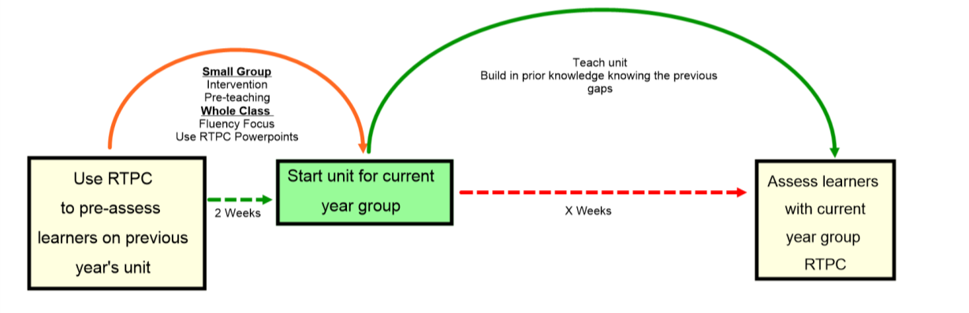
- Formative assessment techniques within lessons
- Pupil Conferencing
- Learning Walk/Lesson Observations
- Work Scrutiny
- Progress review meetings

